The Journey Of banking in the united states

Parth Babbar

9999940289  
  
kishibabbar@gmail.com

**Introduction:**

Banking in the US has a rich and enthralling history that follows back to the last part of the 1700s, when the nation was still in its earliest stages. Prior to the foundation of the primary U.S. banks, individuals depended on using a credit card from banks and shippers in Extraordinary England. Unfamiliar coins and paper cash gave by individual settlements made up the period's money, mirroring the divided and decentralized nature of the early American economy.  
  
**Understanding Banking and Currency:**

**Banking:**

A bank is an organization that makes monetary exchanges. The public authority awards "contracts" to banks. A contract is a report that approves an organization to exist. Banks are not lawful without a contract. Banks take stores from clients and utilize that cash to subsidize speculations, for example, home and business credits and stocks. They vow to keep up with the worth of the client's store, and they offer a level of the benefit they make from their ventures. This is the means by which bank accounts have a loan fee.

A financial frenzy is an exceptional emergency that can make a bank fall flat. All a bank falls flat on the off chance that it needs more cash to pay its stores and obligations. This can occur for some reasons, like a financial exchange crash. Since the Economic crisis of the early 20s of the 1930s, the Government Store Protection Company, or FDIC, has guaranteed stores in banks. This implies that regardless of whether the bank fizzles, the investor's cash is protected. Before the Central bank Framework existed, bank disappointments were normal. One of the objectives of the Central bank is to give soundness to banks and individuals of the US. It assists with doing this by reviewing banks to ensure they are not near coming up short, albeit at times banks can flop regardless of how hard everybody attempts to attempt to help it.  
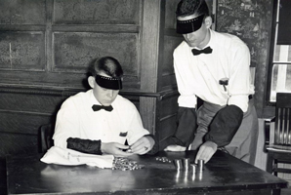

**Currency:**

A cash is an item or gathering of articles utilized in the trading of labor and products. In the US of America, there is money as paper bills and metal coins. These bills and coins address esteem that is offered to one more for something as a trade off, such as paying $1.25 for a jug of pop. Cash was traded for an article that had esteem.

American Cash has had many shapes, sizes, and, surprisingly, various qualities. The US used to have a "Hard Money." This implied that the paper bills utilized in trades had a particular worth in valuable metals, like gold or silver. Presently, the US utilizes a "delicate," or "fiat" money. This implies that the public authority of the US alone backs the worth of the U.S. dollar. Individuals' faith in the US government influences the worth of its money. Every one of the most involved monetary forms in this present reality are government issued types of money.

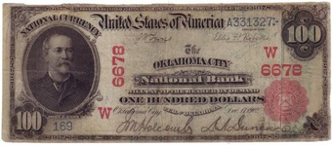

**Early Establishments and Progressive Starting points:**

The colonial era, when commodity money and informal credit systems were the norm, is where American banking began. The monetary scene started to come to fruition during the progressive time frame, as the states looked to lay out financial freedom and steadiness. The beginnings of American banking are exemplified by the following significant occurrences and developments:

1. **1774 – The Intolerable Acts and the First Continental Congress: The Intolerable Acts, also known as the Coercive Acts, were five laws passed by the Parliament of Great Britain in 1774 to punish the Thirteen Colonies of British North America for the Boston Tea Party. In response to British policies, the First Continental Congress was**

**formed, setting the stage for unified colonial action.**

1. **1775 – The American Revolutionary War Begins: The Second Continental Congress convened, marking the start of the struggle for independence.**
2. **1776 – Declaration of Independence: The Second Continental Congress approved and signed the Declaration of Independence, establishing the United States as a new nation.**
3. **1777 – Articles of Confederation: The adoption of the Articles of Confederation provided a preliminary framework for national governance.**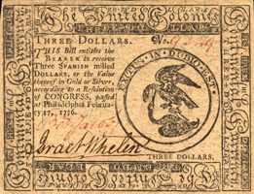

**Foundation of the First National Bank:**

The first formal banks to support the new nation's economy were established during the post-revolutionary period:

1. **1787 :** The Constitutional Convention takes place in Philadelphia
2. **1781 – Bank of North America:** Established by Robert Morris, the Lender of the Mainland Congress, the Bank of North America meant to make major areas of strength for an and store the conflict exertion through credits from France and the Netherlands. Despite the fact that it turned into a confidential bank, it stayed a huge monetary hotspot for the central government during resulting clashes.

**The Requirement for a National Bank:**

The fledgling country's continuous financial difficulties prompted the creation of a central bank to control and stabilise the economy:

1. **1791 – First Bank of the United States:** The First Bank of the United States was established to regulate the nation's currency and finance government operations. It was initiated by Treasury Secretary Alexander Hamilton and was inspired by Robert Morris. Hamilton proposed a 20-year contract as a split the difference to those careful about incorporated power. The bank worked until 1811, when its sanction was not reestablished.

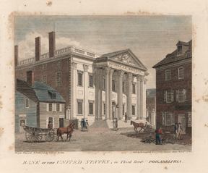

**War and Monetary Unsteadiness:**

The mid nineteenth century was set apart by wars and monetary emergencies that highlighted the requirement for a more vigorous financial framework:

1. **1812 – War of 1812:** The American currency declined in value and gold and silver markets were shut down as a result of the war's massive debt.

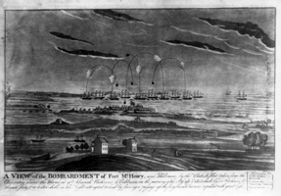

1. **1817 – Second Bank of the United States:** Established in light of the monetary precariousness post-Battle of 1812, this bank was bigger than its ancestor and had a 25-year sanction. It assumed a significant part in balancing out the economy until its contract was rejected by President Andrew Jackson in 1836. 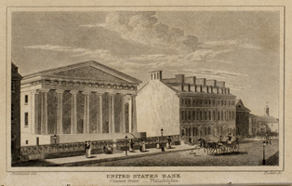  
   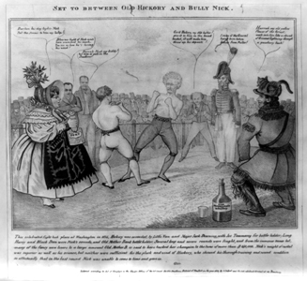

**The Time of Free Banking and Ensuing Frenzies:**

The disintegration of the Subsequent Bank prompted a time of unregulated banking, known as the Free Financial Period, portrayed by various monetary frenzies:

1. **1837 – Panic of 1837:** Set off by an absence of gold and silver money and exacerbated by President Jackson's financial strategies, this frenzy prompted a delayed downturn.

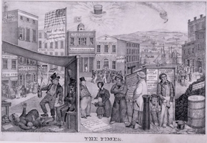

1. **1857 – Panic of 1857:** Brought about via land hypothesis, crashing wheat costs, and railroad disappointments, this frenzy brought about extreme financial slumps, especially in the North.

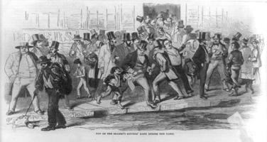

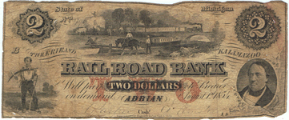

1. **1861 – The Civil War:** The National Bank Act of 1863 was enacted by Congress during the Civil War to establish a national banking system and standard currency under the Treasury. This moved control from state to government authority. The Alliance gave its own money during this time.

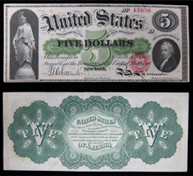

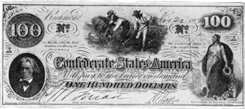

1. **1873 – Panic of 1873:** A worldwide emergency that prompted the Long Sadness, set apart by a huge drop in silver costs and far and wide financial misery.  
   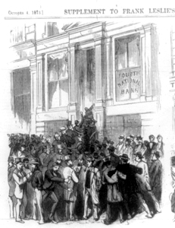

**National Banking System and the Federal Reserve:**

The late 19th and early 20th centuries saw significant reforms aimed at stabilizing the banking system and preventing future crises:

1. **1863 – National Banking Act:** This act laid out an arrangement of broadly contracted banks and presented a uniform cash, making ready for a more incorporated financial framework.
2. **1907 – Panic of 1907:** A severe banking crisis resulted from an unsuccessful attempt to control the copper market, highlighting the need for a central bank.  
   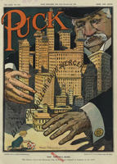
3. **1913 – Federal Reserve Act:** The Central bank Demonstration of 1913 laid out the Central bank Framework, the focal financial arrangement of the US. Its essential goals were to make a more adaptable, stable, and secure money related and monetary framework. The Demonstration made a decentralized design with a Leading group of Lead representatives in Washington, D.C., and 12 territorial Central bank Banks. This framework expects to oversee expansion, moderate long haul loan fees, and guarantee most extreme work through the execution of financial approach.

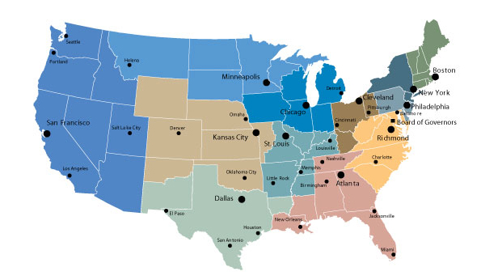

The above map consists of the districts in Federal Reserve System.

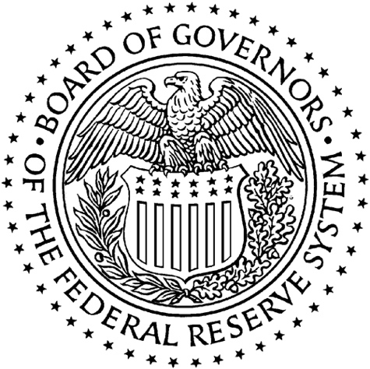

The above is the Seal of the Board of Governors of the Federal Reserve System.

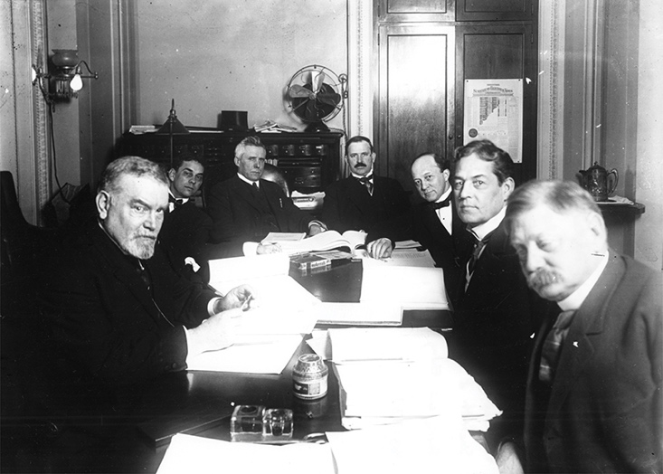

This is an image of the Senate Banking Board of trustees in meeting during the discussion about the Central bank Demonstration of 1913. At that point, Robert L. Owen, envisioned on the right, was top of the board.

**The Great Depression and New Deal Reforms:**

The banking system was on the verge of collapse during the 1930s' Great Depression, which prompted significant reforms:

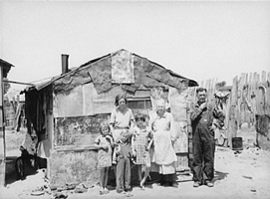

1. **1933 – Glass-Steagall Act:** Isolated business and speculation banking to decrease risk.
2. **Federal Deposit Insurance Corporation (FDIC):** Made to guarantee bank stores, reestablishing public trust in the financial framework.

**Modern Banking and Financial Crises:**

The last 50% of the twentieth 100 years and the mid 21st century saw further developments and difficulties, including mechanical headways and major monetary emergencies:

1. **1982 – Penn Square Bank and the Oil Market Crash:** A collapse in oil prices led to widespread bank failures, prompting significant federal intervention.  
     
   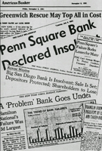
2. **2008 – The Great Recession:** Set off by the lodging bubble burst and exorbitant gamble taking, this emergency prompted huge financial slumps and administrative changes.  
   

**Important People in the History of American Banking:**

**Robert Morris**

Robert Morris, a Philadelphia shipper, was a critical lender during the American Progressive Conflict and the first to push for a national bank in North America, the Bank of North America. He was one of simply two men to sign the Statement of Autonomy, Articles of Confederation, and U.S. Constitution.

**Alexander Hamilton**Alexander Hamilton, the main Secretary of the Depository, laid out the U.S. Mint and the Primary Bank of the US. He co-wrote the Federalist Papers and established the Federalist Party, forming early American monetary arrangement.

**Andrew Jackson**Andrew Jackson, the seventh Leader of the US, energetically went against the Second Bank of the US and is known for wiping out the public obligation. His strategies added to the Frenzy of 1837 and a resulting financial downturn.

**J.P. Morgan**

J.P. Morgan, a prevailing lender, established General Electric and U.S. Steel. He assumed a significant part in settling the U.S. economy during the Frenzies of 1893 and 1907, prompting requires the foundation of the Central bank Framework.

**Robert L. Owen**

Robert L. Owen, a co-supporter of the Central bank Demonstration of 1913, was one of the principal U.S. legislators of Native American plunge. He likewise drove changes in kid work, ladies' testimonial, and the immediate appointment of representatives.

**Conclusion:**

Nowadays, US banking is very helpful to the people who invest in stock market or buy coins as well as the US currency is applicable to all the countries around the globe which makes a person to easily transfer money from one country to another country.